Career Services for Mental Health NEETs:
The WORK4PSY Toolkit

PART C: Tools and Activities

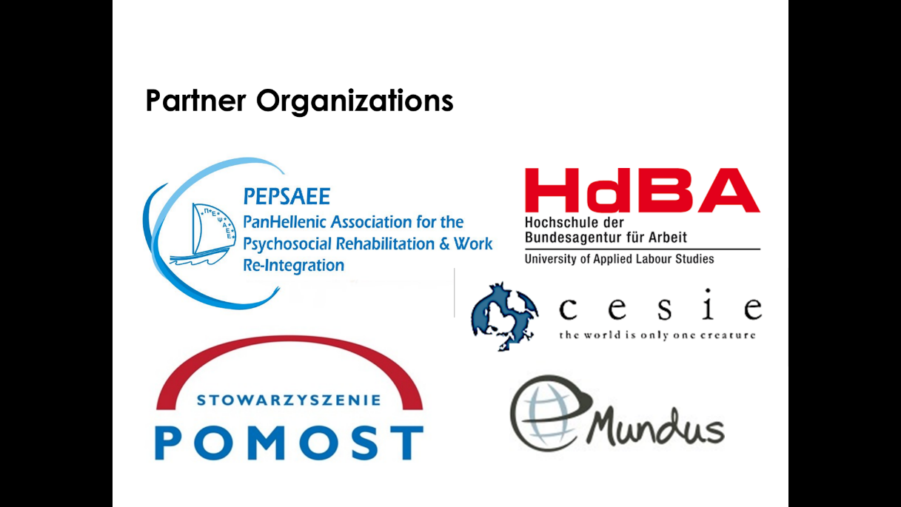

- My World Triangle
    - The activity refers to
Families and informal carers of MH NEETS
    - Aim of the activity
This exercise help families and informal carers of MH persons to identify the support systems they have around them. Very often they feel isolated and cannot see the resources they have close to them. This may include other family members, friends, local organisations, peers or any support system which they can utilise in order to facilitate the return to education or employment of the MH person. Using the world triangle is a useful tool to get families and informal carers of MH persons to visualise who they have in their lives or indeed where they require the most support.
The “My World Triangle” also helps to generate conversation between the families and informal carers of MH persons and the Career counsellors for MH person and can be used in conjunction with other activities.
    - Theoretical framework
“My World Triangle” provides Career counsellors for MH person with a framework that considers every aspect of the families’ and informal carers’ lives. It identifies the strengths or wellbeing concerns in their world; this may include information about the specific needs of the MH person, physical/social/emotional/educational background of the members of their families or any issue affecting their everyday lives which affects their ability to provide care and support to the MH person.
“My World Triangle” considers the families’ or the informal carers’ needs and risks, as well as the positive features in their lives. In many cases, it may not be necessary to gather detailed information on all sides of the triangle if this is not proportionate to the problem. “My World Triangle” is an excellent tool that allows people to explore:
- How they cope with caring for the MH person.
- What they need from the people/organisations who already support them in caring for the MH person.
- What potential support systems are available to them – who they have in terms of friends, community, informal or structural support.
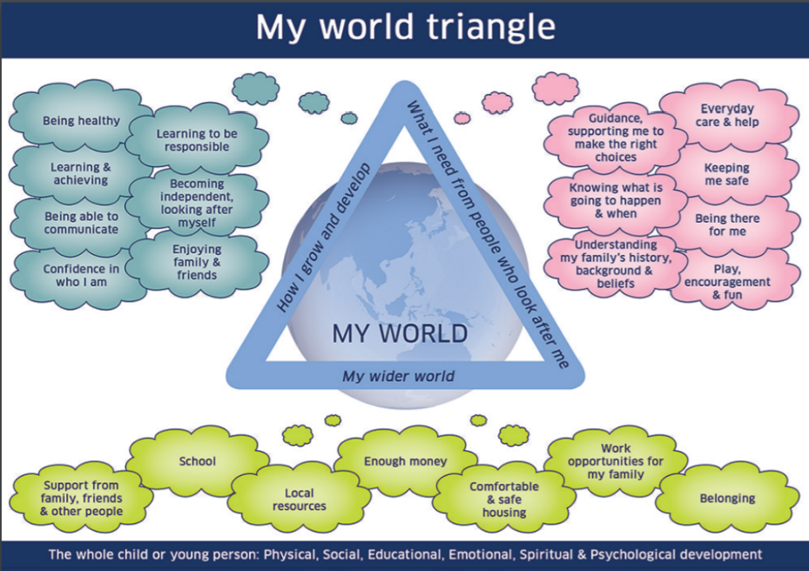
    - Description
Directions
- Introduce the “My World Triangle” to the family member or informal carer (explain what it is and why you are using it).
- Use the heading indicated on the map, it may not be necessary to cover them all.
  - How I grow and develop – it outlines factors in the MH person relating to various aspects of physical, cognitive, social and psychological development.
  - What I need from the people who look after me – it accounts for the critical influences of other people in the MH person’s life.
  - My wider world – the communities where the MH person lives can have a significant impact on the well-being of MH persons and their families and informal carers.
- Encourage them to use the images as a map to identify what barriers or concerns they may have in various areas indicated on the map.
- Encourage them to look at what immediate support they have around them and how they could utilise them if the MH person is to enter education or employment.
- At the end of the session gather the information they have given, reiterate and confirm that the information is correct.
- Use the information gathered to give them further help and support.
Materials required
- Quiet, clean room well-lit/ventilated room
- My World Triangle handout: https://www.careandlearningalliance.co.uk/wp-content/uploads/2016/09/my-world-triangle.pdf
- Table and chairs
- Pen and paper
- Recording devices are a useful tool just in case people have literacy issues. Consent should always be sought from them before recording.
    - Tips
For the practitioner:
- Every practitioner should not feel they have to complete information in detail around the whole triangle. What is important is that they bear in mind that what is happening in one area may have a significant impact on another area.
- There may be overlap between the different dimensions. The important thing is that strengths and pressures are recorded. It is less important where they are recorded.

