Career Services for Mental Health NEETs:
The WORK4PSY Toolkit

PART C: Tools and Activities

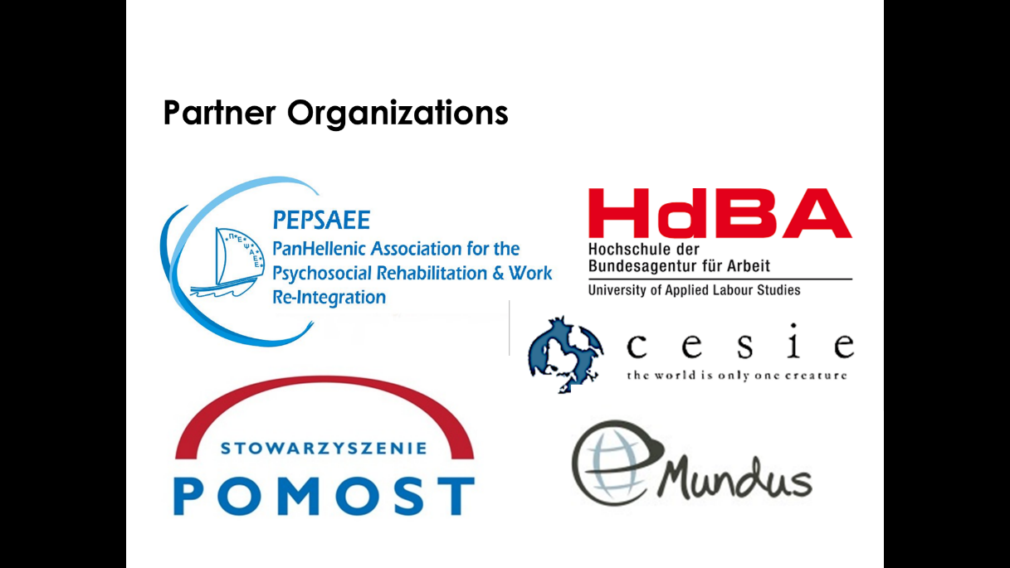

- Positive Notebook
  - The activity refers to: MH NEETS

  - Aim of the activity: The activity aims to assist the person to identify her/his strong points, skills, competence and qualities. This can be the basis for building a sense of, which may further contribute to better achievement of academic and vocational goals.

  - Theoretical Framework: The activity is based on Solution-Focused Brief Therapy and especially on identifying a person’s inner strengths and building self-confidence. The activity was developed by two Polish psychologists and psychotherapists – Anna Biskupska and Anna Mackiewicz. Originally, it was used as part of the program of social readaptation of convicts, and then it was used as part of work with young people, including those with mental disorders.

  - Description: Positive Notebook is a type of notebook in which you will write down a list of your daily duties (see attachment below). Remember one of your typical days. Analyze it from the morning when you get up until you go to sleep. For convenience, you can write the hours in which you perform these activities. Make a note of the list of responsibilities in the left column of Positive Notebook. Then, to each of the duties you perform, add a positive feature that makes you able to cope with this obligation.
Once you're done writing, read the positive qualities list once or twice carefully.

Now consider what are your feelings? What do you think about yourself now? If you come to any conclusion about you, write it down and remember it, it may be one of the most important and "true" conclusions about you.
If you want, you can also show and discuss the completed list with a friend, family member (informal carers) or your counsellors.

Attachment

List of duties that I perform during the day | What is the positive quality that I can cope with this duty?

