Career Services for Mental Health NEETs:
The WORK4PSY Toolkit

PART C: Tools and Activities

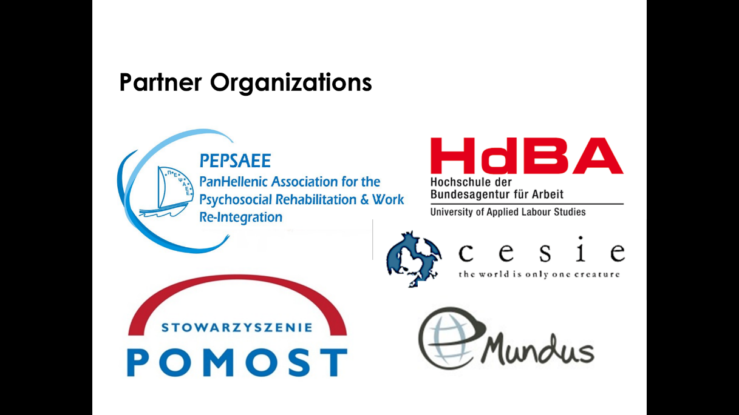

3. Self-esteem Journal

Monday | Something I did well today…
 | Today I had fun, when…
 | I felt proud when…
Tuesday | Today I accomplished…
 | I had a positive experience with…
 | Something I did for someone…
Wednesday | I feel good about myself, when…
 | I was proud of someone else…
 | Today was interesting because…
Thursday | I felt proud when…
 | I positive thing that I witnessed
 | Today I accomplished
Friday | Something I did well today…
 | I had a positive experience with (a person, place, or thing)…
 | I was proud of someone when…
Saturday | Today I had fun when
 | Something I did for someone
 | I feel good about myself when…
Sunday | I positive thing that I witnessed
 | Today was interesting because…
 | I felt proud when…

